Doc 41 Amends and additions

Major section needs building SET UP / ADMINISTRATOR.
- A section needs building where the administrator (main user) gets to set up other users, add their emails, name and approval limits (if any).
- This could be where structures for site numbers and po numbers are set (see below comment r.e. site numbering Developments 2.))
- Perhaps cost codes are put in here and can be reviewed (albeit very risky changing things if existing orders are in place and say someone removed a cost code or move them around. It could break historic data).
Developments:
- New development green box twice on the screen
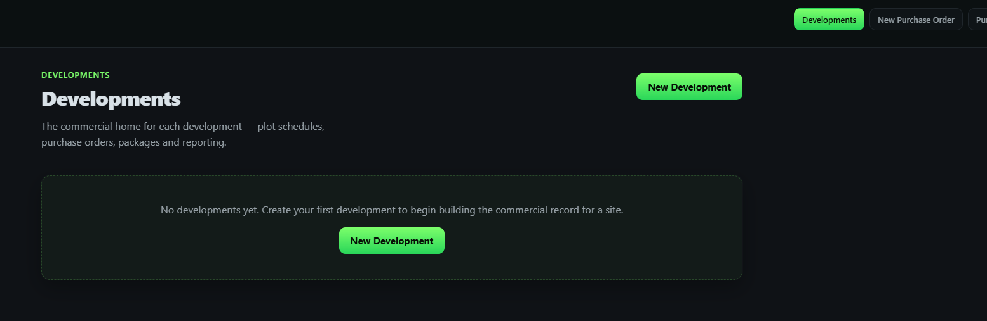

- Should the Development number be auto generating? I.e Buildlite becomes the source of site numbering so that duplications cant be made?
- What is the purpose of the ‘Client’ box. As this will be used by developers for themselves there would’nt be a client as such.
- Drop down date selection boxes still not working (don’t know if there were addressed in the last batch of fixes)
- A bit of an overlap with the date boxes:
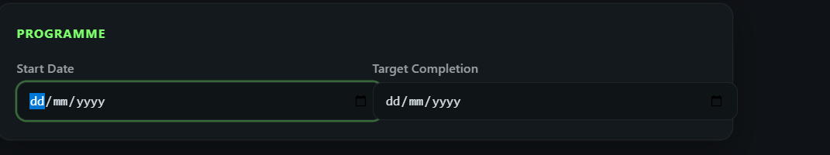
- Developments has a button for packages. This seems to just be a list. Would it be useful to be able to open the package here and create a certificate as a second way other than the payment certs ‘module’ button?
Import Plot Schedule
- Still doesnt have an option to populate the configuration

Purchase orders:
- As is correct I cant delete and order once approved, however there is an option to delete and a note that appears warning ‘this cannot be undone’, however on pressing delete, it doesn’t delete it.
- On setting up a supplier there should be a requirement to set them as Sub-Contract or supplier. This should then dictate the type of order being raised. I have in error raise two orders now accidentally as material for a sub-con bricklayer. This obviously doesn’t then land in ‘packages’.
- This opens another thought! Should a cost code be fixed to sub-con or supplier? Or do we allow a costs code to be either (which could be useful in a few circumstances). Perhaps it should be the suppler / sub-contractor that is fixed to what sort?
- Suppler set up again. Should they not have their VAT rate defined? Or are we going to rely upon the company (SME developer / user) to dictate a default as we did in the set up wizard?
CVR and Ledger:
- It feels to me like we need a CVR landing page where all the CVRs from No. to the current are listed. There needs to be a locking facility which can only be done by the authorised person (usually the FD / MD).
- I also think that once in the ‘new CVR’ or first CVR the ledger import should sit there? It feels a bit disconnected where it currently is. Its like another task to do before going in to the CVR module.
- Another big thing here is the one-page headline summary of the CVR. This is the bit that all board members review in CVR meetings. One page with the key cost heads (R&S, Plot works, Housebuild, Prelims, Sales etc) with previous totals and current and also with eh original budget for comp. This then needs all the key metrics of profit £ & %.
- The CVR is currently just a list which for example on COINS that would be just one tab of many. Most of the others on coins are just reports and data but the revenue tab is crucial. All we are looking at here are costs
- We need prelims to be be more intuitive and possibly set up different we need the same columns in the cvr as well as some durations driven by the site programe and needs to be adjustable. This is where COINS is week asn external spreadsheets are needed. I would like to get away from that. The same applies to selling costs
- I think we need to be able to collapse the huge list of CVR lives or find a filter button that brings up – Land, Fees, Prelims, Plot works, Externals, housebuild, selling costs etc. they could be different tabs altogether allowing for different formatting.
Ledger:
- Could we have the Continue to import button at the top of the ledger list rather than scrolling all the way to the bottom?:
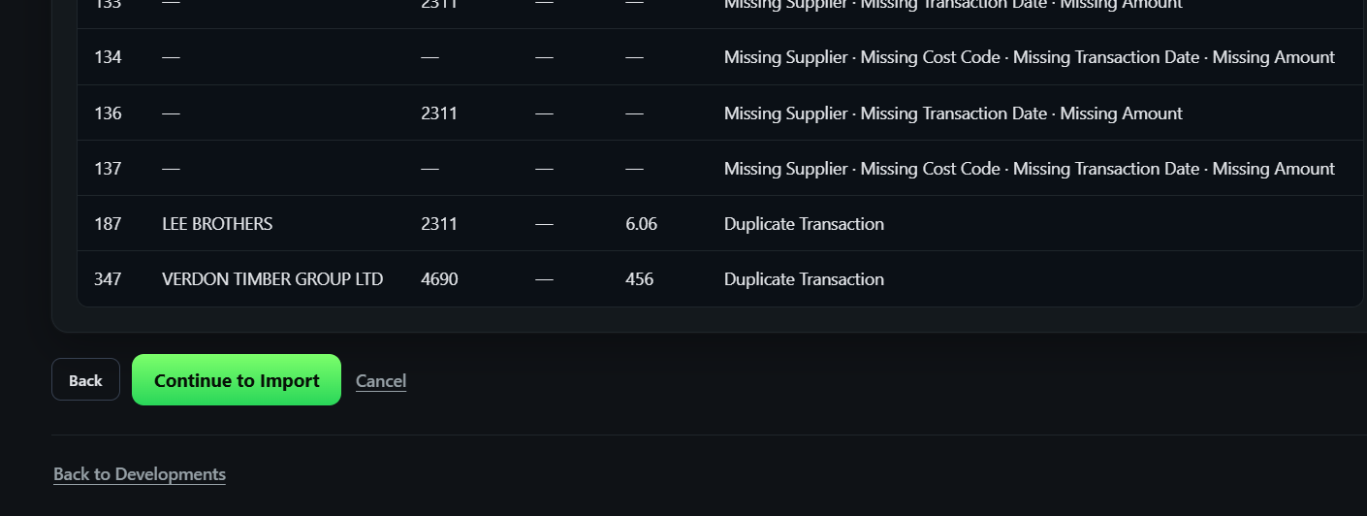
- How do we manage the import of costs from ledger to CVR. I.e. Should we just add the months (or CVR period that could be monthly bi-month or quarterly) onto the previous lot or have to upload the whole ledger each time. The whole thing feels safer but could that make work?

